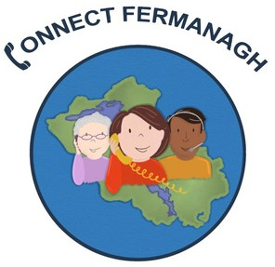

Service Co-ordinator
Application Form

Your details

Name:

Address:

Postcode:

Phone:

Email:

Education and training
Please give details of all qualifications and Certificates achieved including date achieved and grades/marks:

Employment history
Your current or most recent employer

Name of employer:

Address:

Postcode:

Job title:

Pay:

Length of time with employer:

Reason for leaving:

Duties:

Previous employment
Please tell us about previous work, paid or voluntary.

Relevant Training and Experience

Please tell us about your experience of supervising Volunteers or Staff.
(Maximum 200 words)

Experience of working with a range of agencies including statutory, voluntary and community service providers.
(Maximum 200 words)

Please tell us about your knowledge, skills and experience of Safeguarding including any relevant Training with dates.
(Maximum 200 words)

Please tell us about your Administrative and ICT skills.
(Maximum 200 words)

Supporting statement
Please tell us why you applied for this job and why you think you suited to this position.

Driving
Do you have:

Valid Driving Licence: Yes / No

Access to a Car: Yes / No

Interview arrangements and accessibility
Please tell us if there are any reasonable adjustments, we can make to help you in your application or with our recruitment process.

Notice period
If relevant, do you need to provide notice to your current employer and if so, how long is your notice period?

Right to work in the UK
Do you need a work permit to work in the UK? Yes / No

References
Please give the names and contact details of 2 people who we can ask to give you a reference.
Referee 1
Referee 2

Declaration
I confirm that to the best of my knowledge the information I have provided on this form is correct and I accept that providing deliberately false information could result in my dismissal.

Name:

Signature:

Date:

Please return your application form either by post or email to:

Sonya Johnston
Fermanagh Trust
Fermanagh House
Broadmeadow Place
Enniskillen
BT74 7HR

Email:
Sonya@fermanaghtrust.org

Closing date: 12noon, Monday 11th May 2026

